DAY8 SESSION ASSIGNMENTS(Theory)

1.When to use (Rapid Application Development) RAD model ?When not to use (Rapid Application Development) RAD model

RAD model can be used in the following cases:-

- When we want to deliver a project in a short span of time
- When the user will be involved all through the life cycle
- When there is high availability of designers for modeling
- When the functionality of the project is delivered to the customer as increments
- When the technical risks identified in the projects are less
- When the system shall be modularized
- When the budget permits use of automated code generating tools
- When domain experts are available with relevant business knowledge
- When the systems are component based and scalable

Following are the cases in which RAD model is not suggested:-

- When the system cant be modularized
- When there is no technically strong team
- When the projects are to be delivered in a large span of time
- If there is no good budget plan
- If efficient designers are not available for modelling

2.Define an ER diagram of a software Organization with all the relationship model that was discussed in the classroom

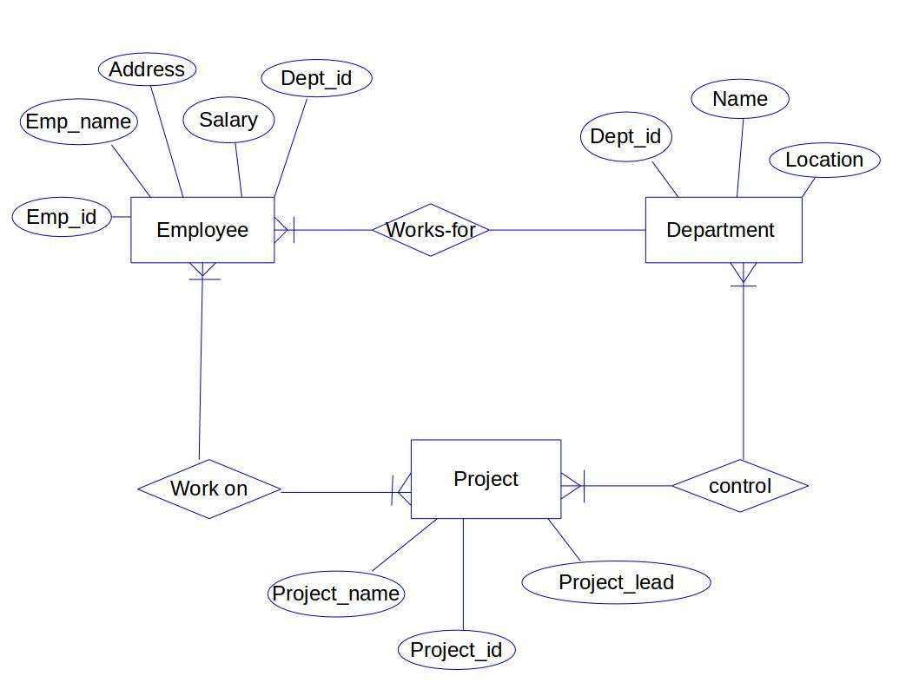

3.Describe the Entity Relationships for the following diagram

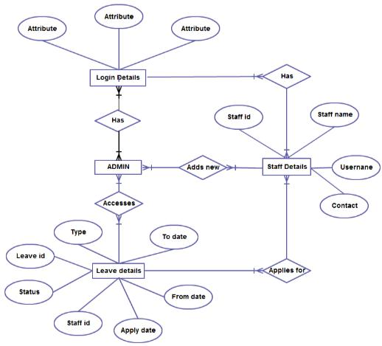

The entities are:-
* Login Details
* ADMIN
* Staff Details
* Leave details
Corrresponding to each entity there are many attributes and they are as follows:-

Entity | Attributes
Login Details | Attribute,Attribute,Attribute
ADMIN
Staff details | Staff id,Staff name,Username,Contact
Leave details | Leave id, Status,Staff id, Apply date,From date,To date, Type

Different type of relationships:

- Has: one or more admin has one or more login details(many to many relation).
One or more staff has one or more login details(many to many relation).

- Applies For: one or more staff applies for one or more leave(many to many relation).

- Leave Details:one or more admin accesses one or more leave details(many to many relation).
- Add new: Admin and Staff details has a Many-to-Many relationship where the relationship is Add new

